IMPORTANT PLEASE READ
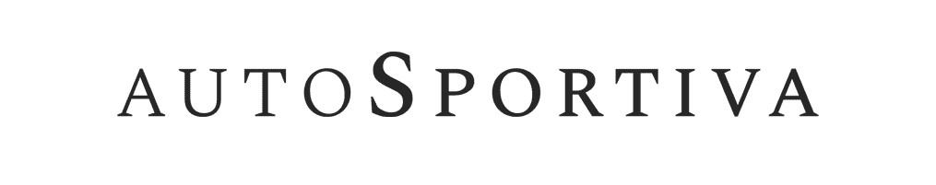

Initial Disclosure Document
Dear Customer
Please read the following document in addition to your pre-contract information and SECCI. You should consider the information given in all documents before signing your finance agreement.
Financing your purchase – Frequently Asked Questions
Who Are We?
Auto-Sportiva Ltd. Company registration number - 06694348. Our registered address is Unit 10 Adam’s Wharf, Branbridges Road, East Peckham, Tonbridge, Kent TN12 5HD.

What can we do to help finance your purchase?
We are authorised and regulated by the Financial Conduct Authority for credit brokerage. Our FCA number is 666762. Auto-Sportiva Ltd is a credit broker, not a lender. We can introduce you to a limited group of carefully
selected credit providers who may be able to offer you finance for your purchase. Each credit provider
may have different interest rates and charges. We do not charge you a fee for our services.

Rates will be either fixed based on the lender or based on your credit score. Credit score-based rates are pre-set but are also linked to your individual credit rating. Typically, the higher your credit score, the lower the APR you will receive from a credit provider. Fixed rates are determined by our contractual agreements and we cannot change this rate.

We are only able to offer a range of finance products from these providers, which may be suitable for you and we will explain the key features of these products to you. We will receive payment from the credit provider for introducing you to them. The amount of commission received could vary by credit provider, which may be a higher amount in relation to certain products compared with other products available. The credit providers we work with will pay commission at different rates. However, the amount of commission that we receive does not have an effect on the amount that you pay to the lender under your credit agreement.

Can we give you independent financial advice?
We are NOT independent financial advisors and are unable to give you independent financial advice. We will provide details of the products available from the credit providers that we work with, but no advice or recommendation will be made. You must decide whether the finance product is right for you.

Using your personal data
Please read our Privacy Notice as the personal data you provide is being processed by the funders we use for finance. Site Pages | Auto Sportiva (auto-sportiva.com)

What can you do if you wish to complain about our services?
If you wish to make a complaint, please contact us in the first instance by writing to us at Customer Services Department, Auto-Sportiva Ltd, Unit 10 Adam’s Wharf, Branbridges Road, East Peckham, Tonbridge, Kent TN12 5HD or by telephoning us on 01732 450731.

You have the right to refer any unresolved complaint to the Financial Ombudsman Service, South Quay Plaza, 183 Marsh Wall, London, E14 9SR.

Web: www.financial-ombudsman.org.uk Telephone: 020 7964 1000
Fax: 020 7964 1001 Email: complaint.info@financial-ombudsman.org.uk

